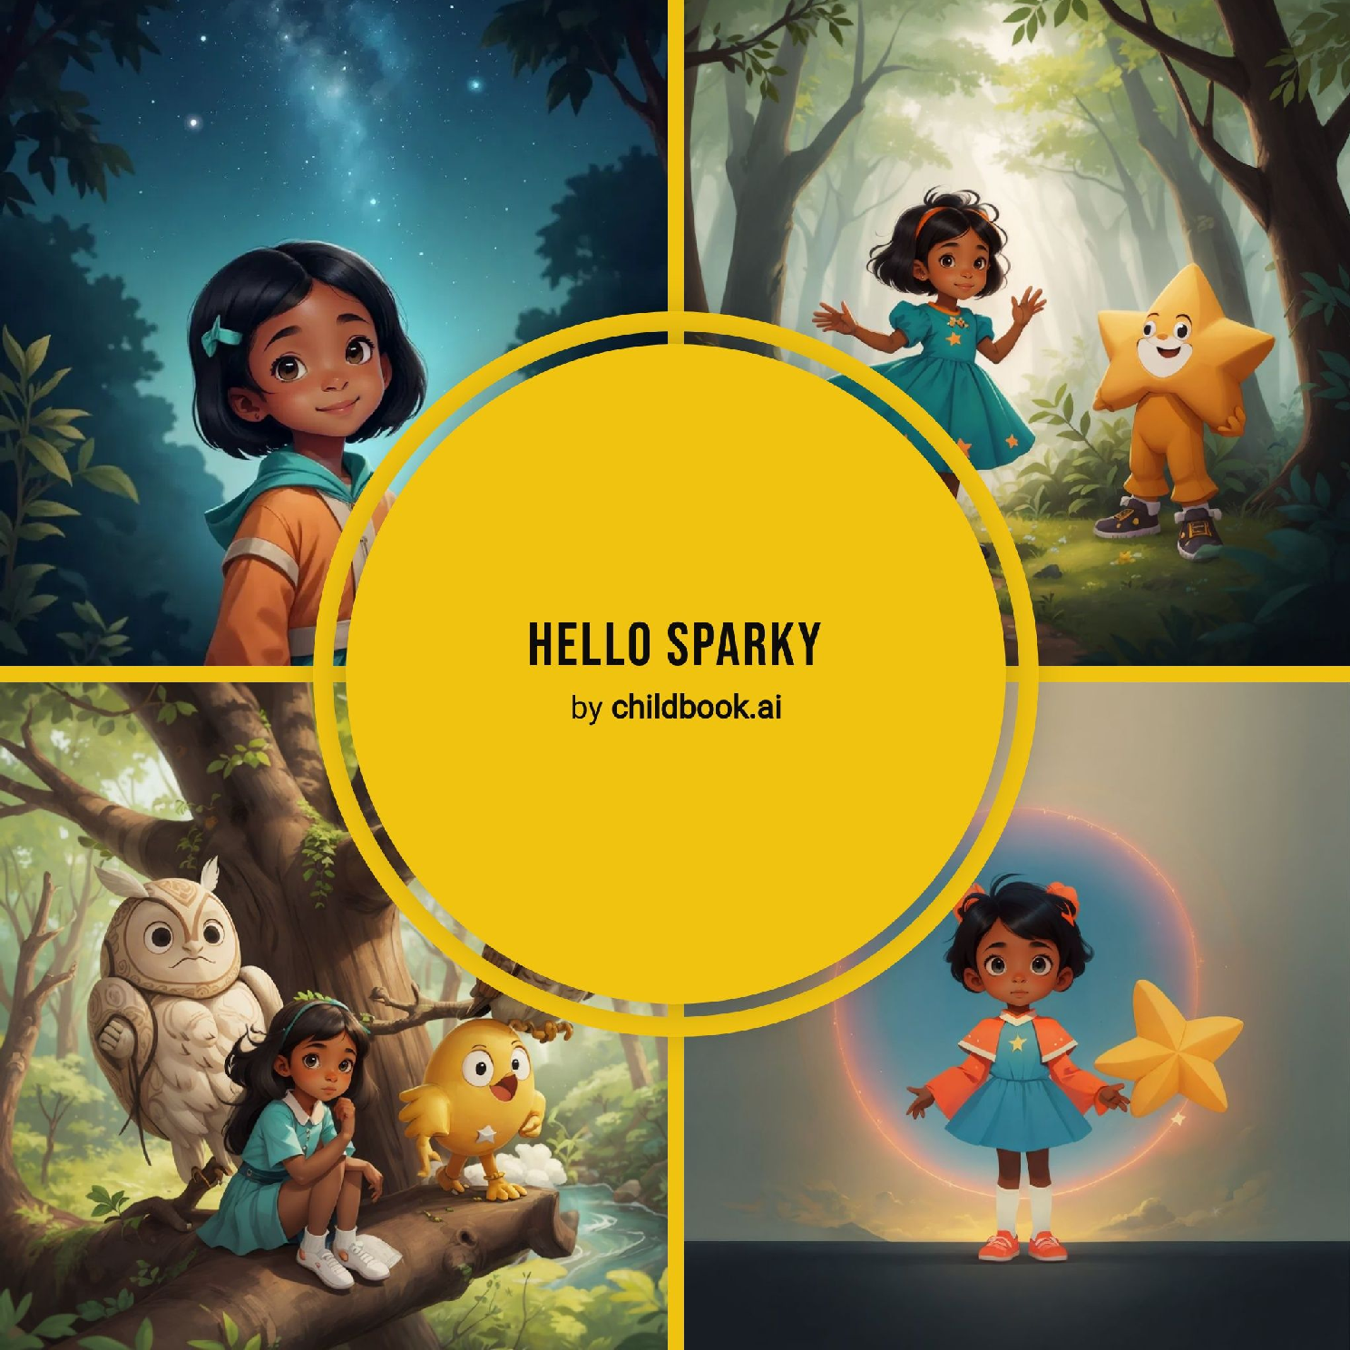

Yuni loved looking at the stars every night, dreaming about her parents. The stars always twinkled brightly, but lately, they seemed dim. One night, Yuni saw a star fall from the sky and land deep in the woods. Curiosity filled her heart, and she decided she had to find it. She hoped that finding the star would bring magic back to the world.

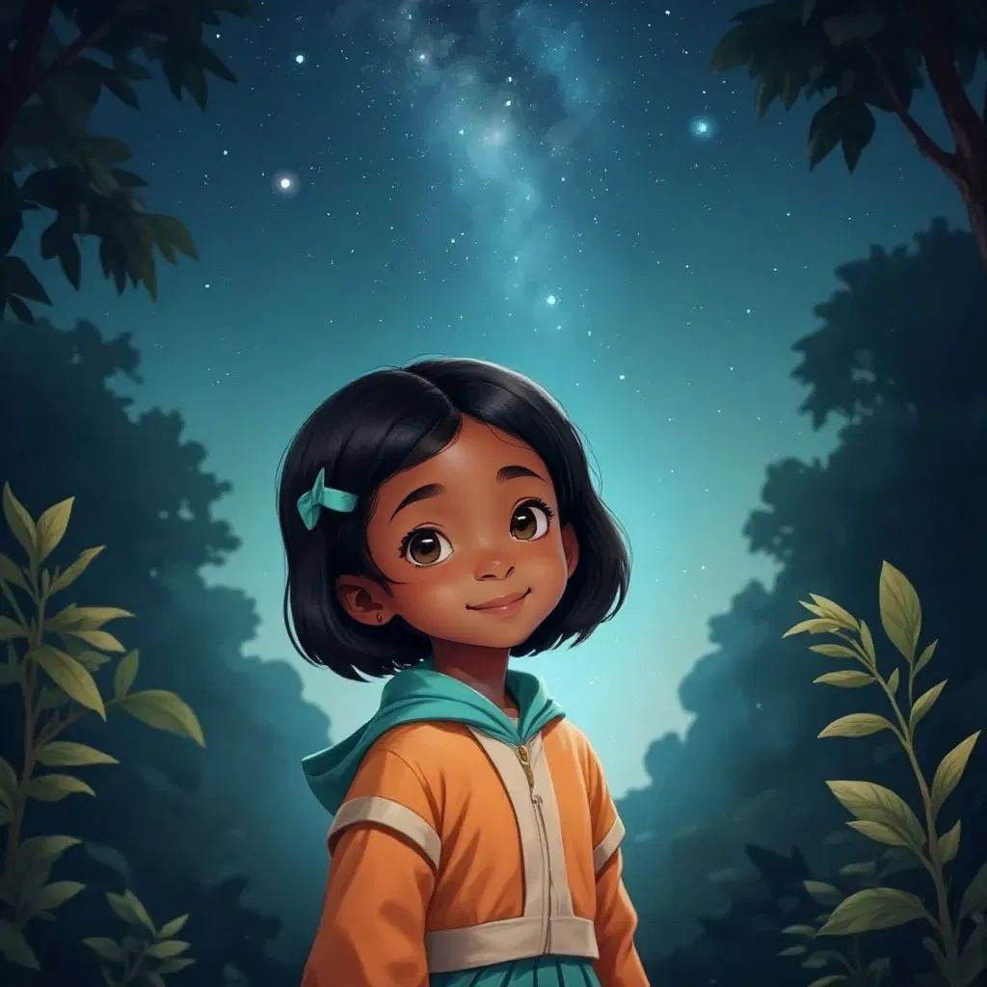

Yuni ventured into the woods where the star had fallen. She discovered a small, star-shaped being standing there. This being had arms and legs, just like her, and wore white gloves. It looked lost and confused, not knowing who it was. 'I'll call you Sparky,' Yuni said with a smile, deciding they would find Sparky's memory together.

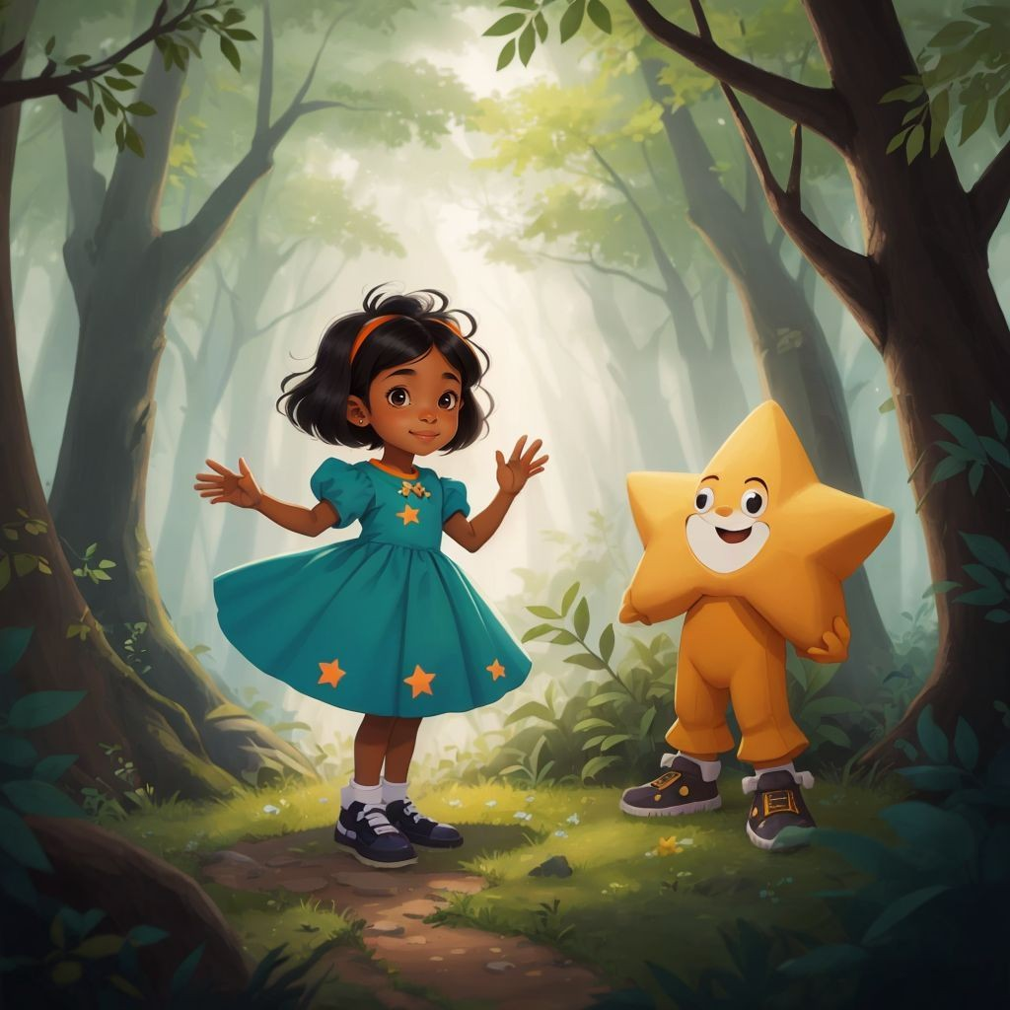

Yuni and Sparky began their adventure to restore Sparky's memory and discover why the world was forgetting. They met Wise Owl, who gave them the first note of a forgotten song. The Ancient Tree shared stories from long ago, and the Playful River taught them a melody. Each guardian helped them gather pieces of the memory puzzle. Together, they made their way toward a place called Nowhere.

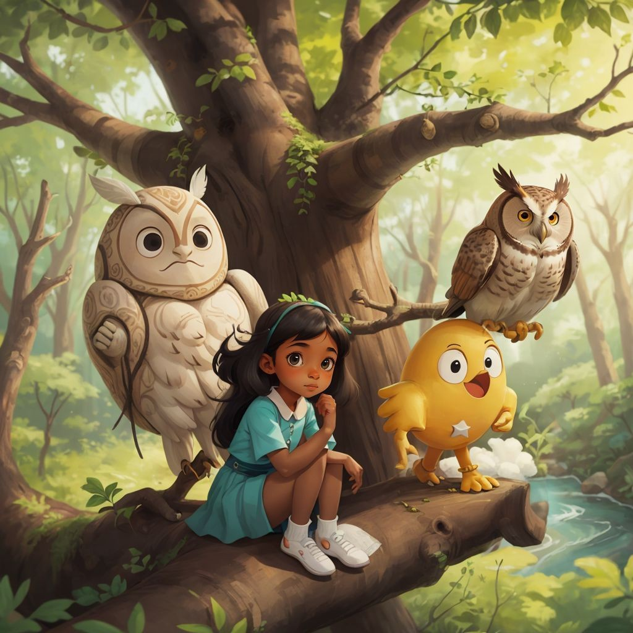

In Nowhere, Yuni and Sparky met No One and No-Thing, where all memories begin. Sparky realized she was the spark needed to light up the world again. With a glowing burst, Sparky vanished, restoring light and connection everywhere. Yuni woke up, remembering Sparky with a warm song in her heart. Back at the orphanage, a kind couple adopted her, bringing along a joyful puppy named Sparky.

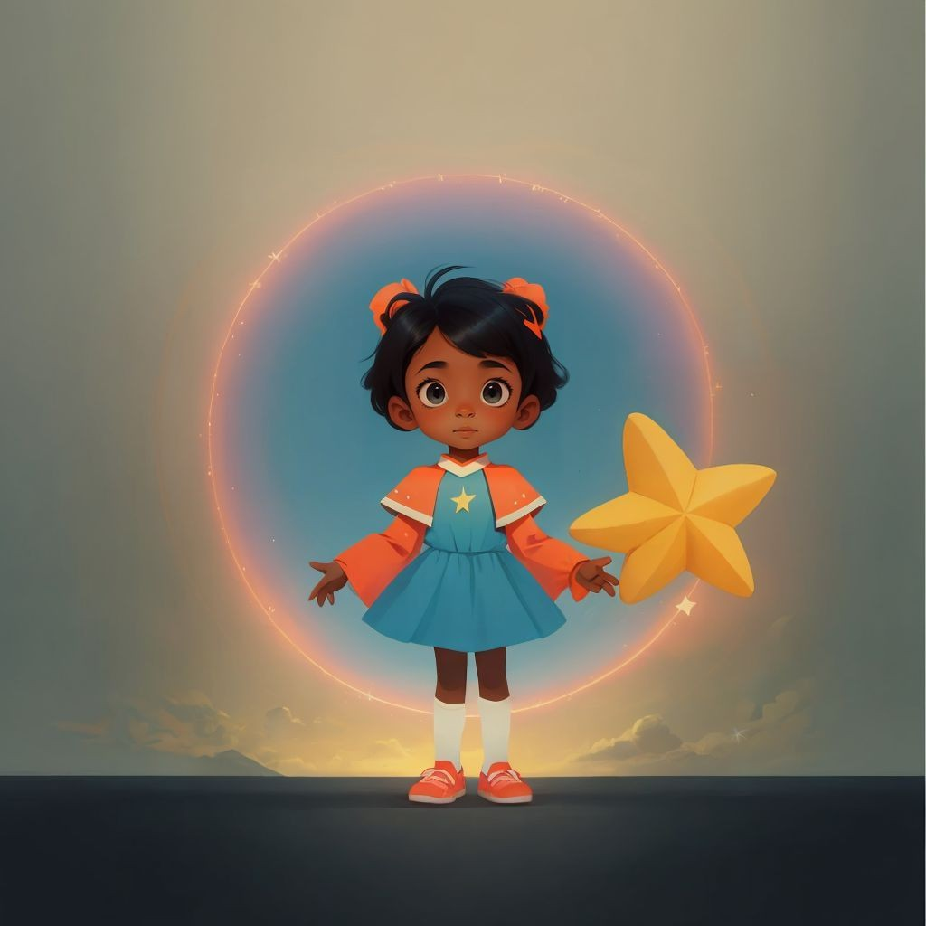

SPARK YOUR CHILD's IMAGINATION

AND CREATE PERsONALIZED CHILDREN's BOOKs WITH CHILDBOOK.AI!

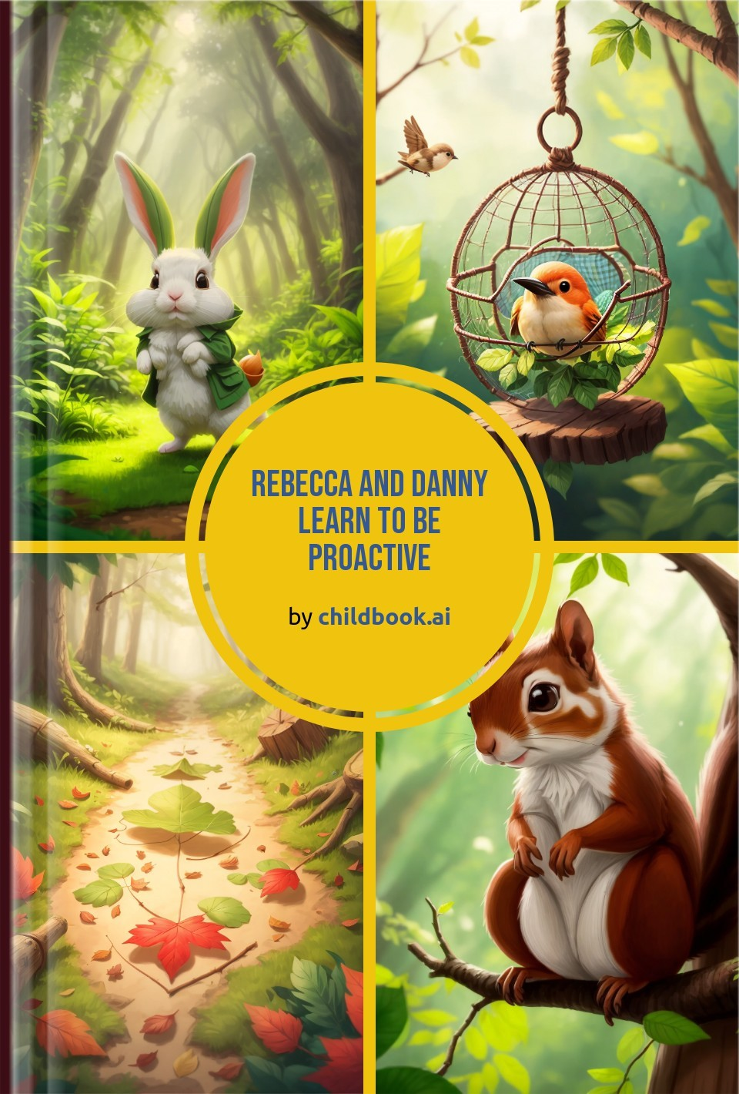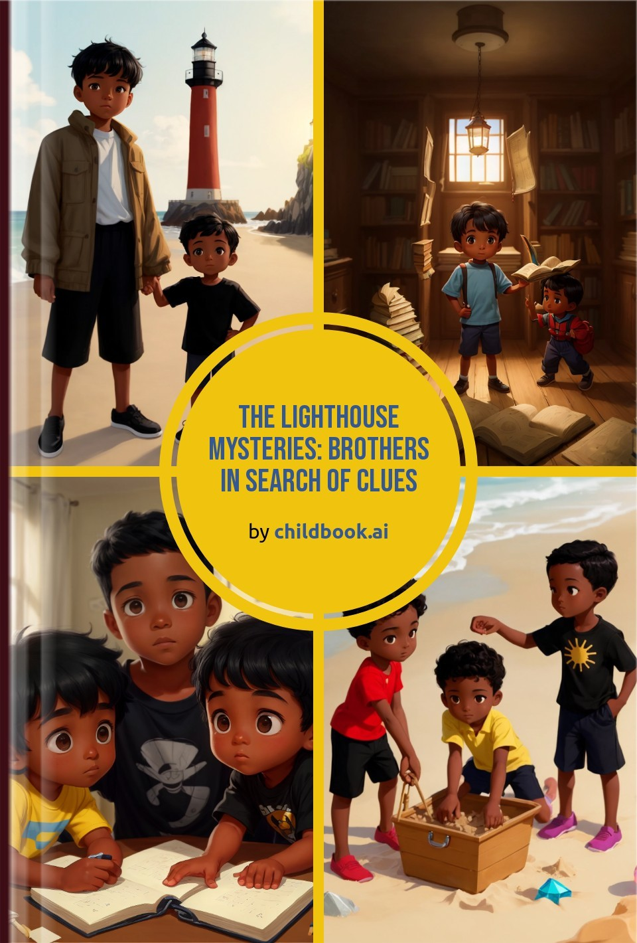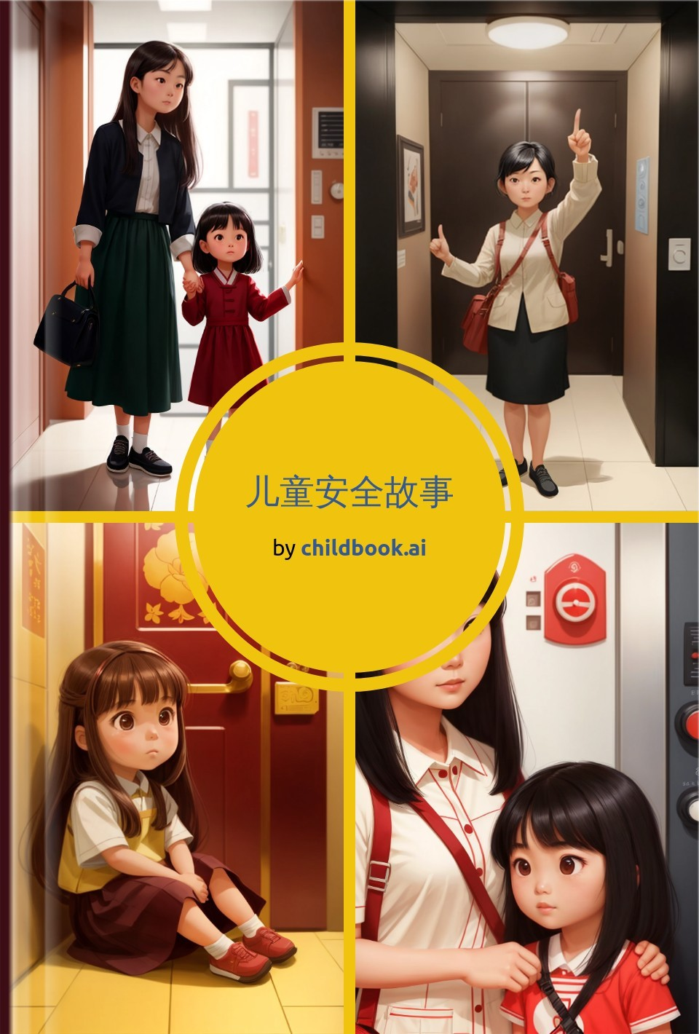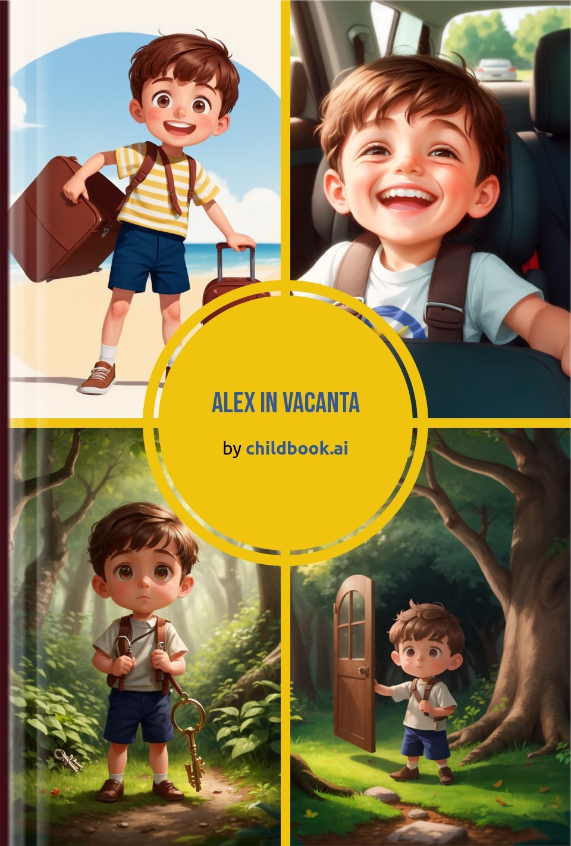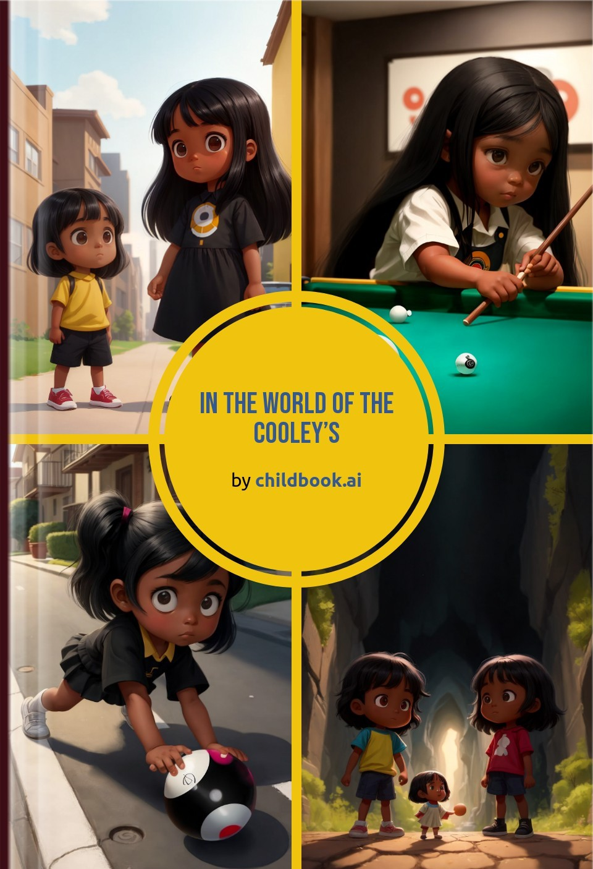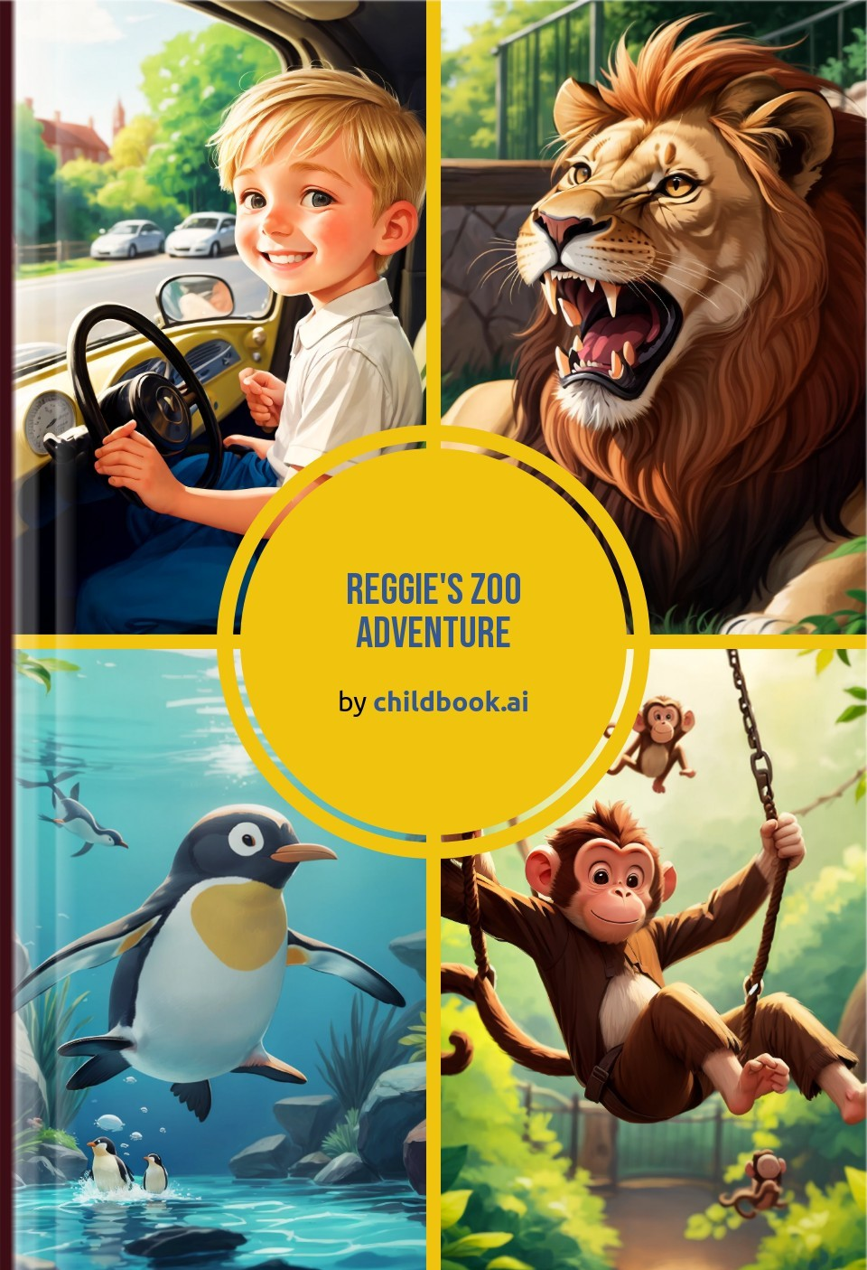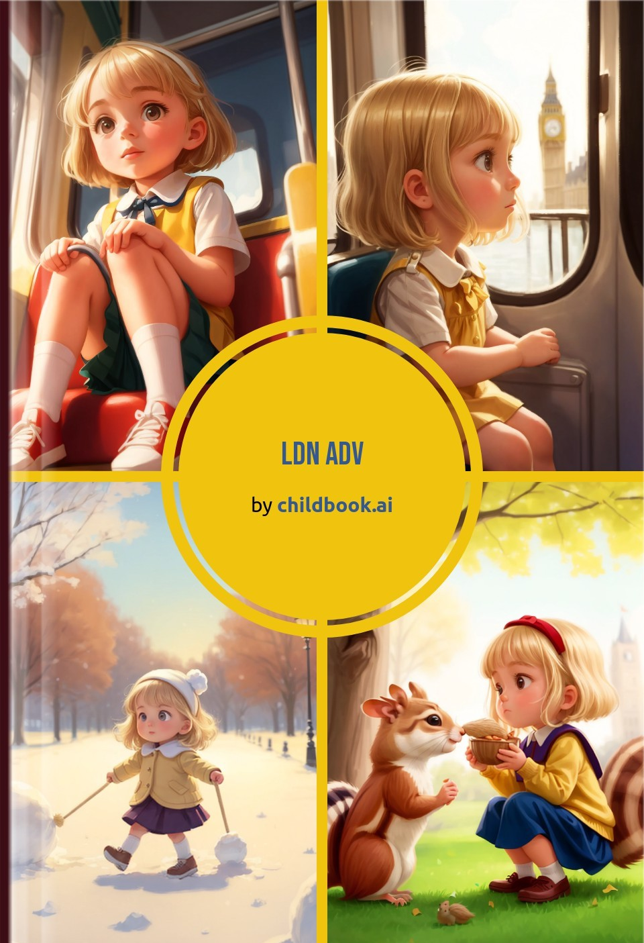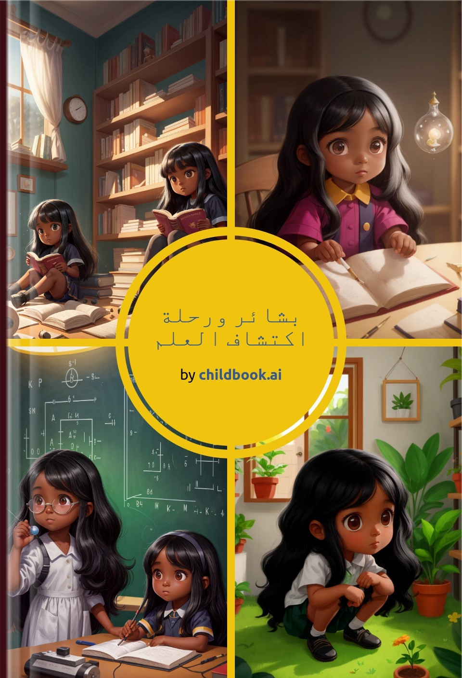

Create a unique children's story with our easy-to-use ai storybook maker. Our personalized children's books are fully customized with original characters, illustrations, and an imaginative plot.